What to expect at my first Pony Club rally
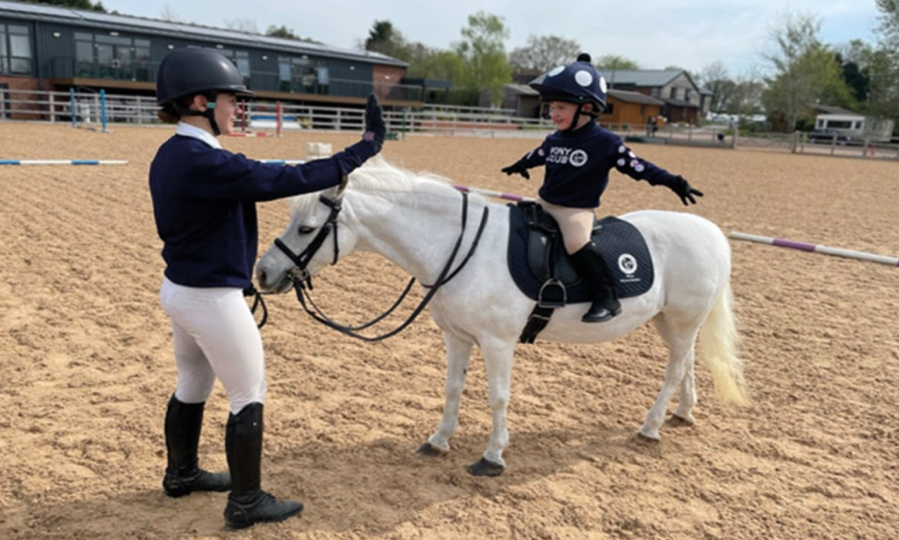
Before your rally
⭐️ Make sure you know what is expected:

Ponies need to be vaccinated within the rules to attend anything with Pony Club to keep them and other ponies safe:
https://resources.pcuk.org/wp-content/uploads/2024/08/The-Pony-Club-Equine-Influenza-VACCINATION-RULE-.pdf

⭐️ If you have any reasonable adjustments fill in this form and let the rally organiser know as far in advance as possible:
Under 12’s: https://resources.pcuk.org/wp-content/uploads/2023/12/pony-club-personal-profile.pdf
Over 12’s: https://resources.pcuk.org/wp-content/uploads/2023/12/pc-personal-profile-form-12.docx
Policy: https://resources.pcuk.org/wp-content/uploads/2023/12/reasonable-adjustment-policy.pdf

⭐️ What to wear :
️The dress code for ‘Tack & Turnout’ rallies in the summer months can be found here: https://branches.pcuk.org/lancaster/wp-content/uploads/sites/423/2024/03/TT-Rally-Checklist-1.pdf

Points are awarded across the summer tack & turnout rallies with trophies awarded at our annual Awards Night for the winners

Winter rallies have a more relaxed dress code: https://branches.pcuk.org/lancaster/wp-content/uploads/sites/423/2024/03/Winter-Rally-Checklist-1.pdf

⭐️ The most important thing is to make sure riding hats, boots, stirrups and tack are all safe. Pony Club sets the following standards:
Hats - https://resources.pcuk.org/wp-content/uploads/2024/08/Hat-Rule.pdf
Stirrups - https://resources.pcuk.org/wp-content/uploads/2024/08/Stirrup-Rule.pdf
Body protectors - https://resources.pcuk.org/wp-content/uploads/2024/08/Body-Protector-Rule.pdf
Spurs - https://resources.pcuk.org/wp-content/uploads/2023/12/the-pony-club-guidelines-on-the-use-of-spurs.pdf
Tack - https://resources.pcuk.org/wp-content/uploads/2024/03/Dress-and-Tack-Rev-2024.docx

⭐️ Rally Groups - You will be matched as closely as possible by ability and age to a suitable group

⭐️ There will be a time slot provided approximately two days before on the WhatsApp community. This will also tell you which arena you are riding in and who is teaching. We often need help setting out and packing away equipment so please allow time to help - Many hands make light work as they say!

On the day
⭐️ Make sure you arrive in plenty of time
⭐️ If you haven’t already, find one of the committee members to have your hat tagged (if the hat is not to the current standard sadly you won’t be allowed to ride so check the link above to make sure).
⭐️ Mount and line up with the other members ready for your tack check
⭐️ Your coach will ask you some questions about your pony and your experience whilst they check your tack and equipment is safe.
⭐️ Now the rally begins!

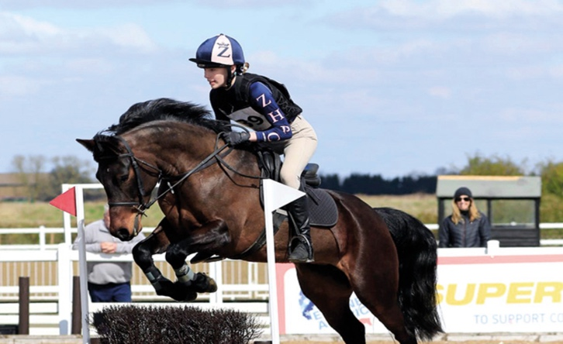

Important
During the rally:
❗️ALWAYS follow the coach’s instruction
❗️STAY in walk around the coach unless they tell you otherwise
❗️ALWAYS listen to your coach and ask if there is something you don’t understand
❗️TELL the coach if there is anything that worries you or if there is something your pony hasn’t done before so they can help or adjust the exercise if needed
❗️LEADING, a parent or over 16yrs old helper can lead you if it helps.
Parents
❗️Under 5’s to be on the lead rein unless agreed with the coach it is safe to be off lead
❗️Lead reins to must only be attached to the back of the noseband (never the bit)
❗️ Be prepared to scoop your pony’s poop as it falls!
This is the only time we you should enter the arena unless leading or invited by the coach

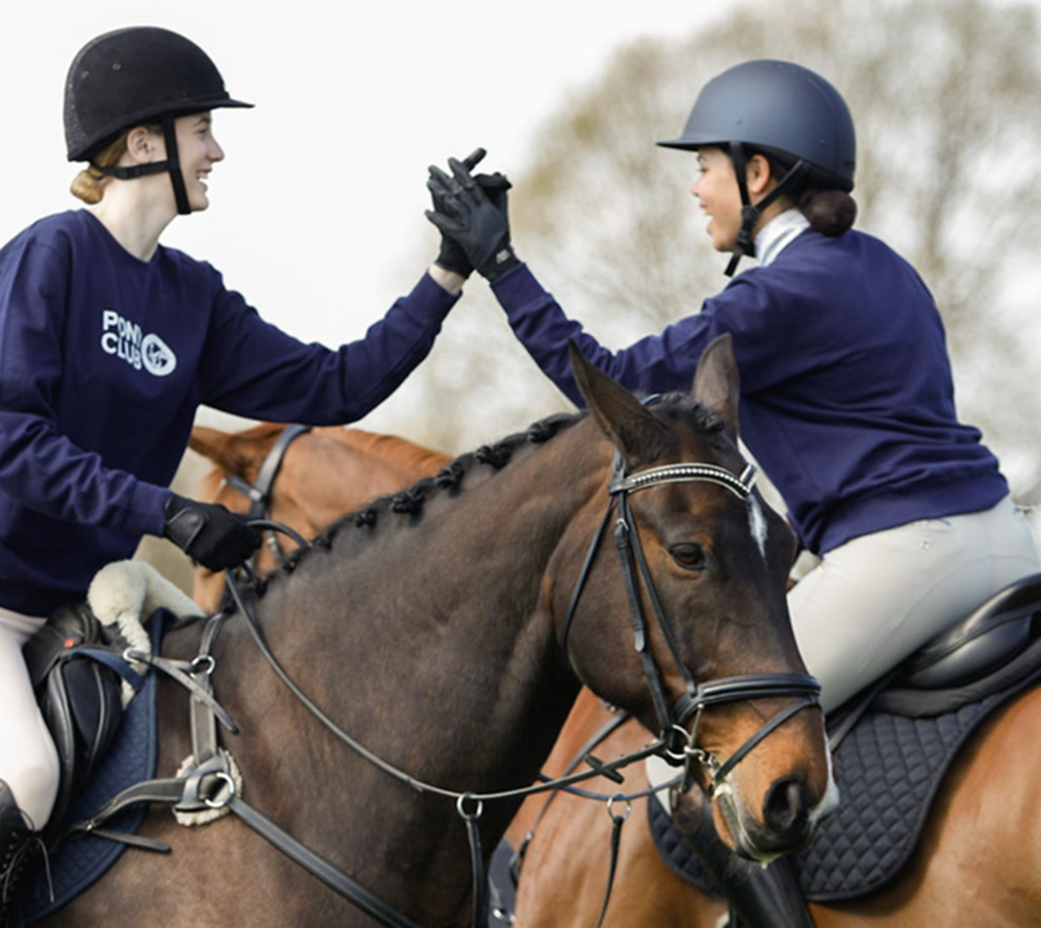

Well done and see you next time!

